MECHATRONIC SYSTEM INTEGRATION
(MCTA 3203)

SEMESTER 2,2025/2026

EXPERIMENT 5 :
SMART SURVEILLANCE CAMERA USING ESP32-CAM
(MCTA 3203)

SECTION 1

GROUP 8

NO. | MATRIC NO. | NAME
1 | 2416289 | MUHAMMAD IRFAN HAKIMI BIN MOHD RIZUAN
2 | 2128653 | MUHAMMAD NAJMI BIN MOHD AZAM
3 | 2120279 | MUHAMMAD SHAHABUDIN BIN ISHAK

SUBMISSION DATE: 15 APRIL 2026

ABSTRACT

This experiment explores the integration of Internet of Things (IoT) capabilities with mechatronic actuators to develop a smart surveillance system. Utilizing the ESP32-CAM module and OV2640 camera sensor, a live video streaming server was established over a Wi-Fi network. The system incorporates real-time hardware response by interfacing a servo motor for horizontal panning, controlled via Pulse Width Modulation (PWM). To enhance interactivity and automation, a manual trigger was implemented using a pushbutton on GPIO 13 to control panning sequences. Furthermore, the system leverages the ESP32’s digital signal processing capabilities to enable face detection, allowing for active motion tracking based on coordinate feedback. The results demonstrate a practical foundation in wireless data transmission and the synchronization of software algorithms with physical system automation.

TABLE OF CONTENT
ABSTRACT 2
TABLE OF CONTENT 3
OBJECTIVE 4
INTRODUCTION 4
MATERIAL AND EQUIPMENT 5
EXPERIMENT SETUP 5
DATA COLLECTION 6
DATA ANALYSIS 7
RESULTS 8
DISCUSSION 9
CONCLUSION 9
RECOMMENDATIONS 10
REFERENCES 10
ACKNOWLEDGEMENT 11
STUDENTS DECLARATION 11

OBJECTIVE

By the completion of this lab, the following objectives will be achieved:
- Wireless Vision Integration: To interface and stream live video data from the ESP32-CAM (OV2640) module to a web-based interface via a Wi-Fi network.
- Mechatronic Actuation: To implement horizontal camera panning by controlling a servo motor using Pulse Width Modulation (PWM) signals.
- Manual Control Logic: To integrate a pushbutton on GPIO 13 to manually trigger and interrupt the servo's motion, demonstrating discrete signal input handling.
- Automated Feature Detection: To utilize the face detection capabilities of the ESP32-CAM and interpret coordinate systems to enable active tracking of subjects.
- System Synchronization: To demonstrate the synchronization of software algorithms with physical hardware responses, specifically bridging digital signal processing with real-time automation.
- Power & Signal Management: To understand and apply proper hardware interfacing techniques, including the use of an external 5V 2A power supply for high-current actuators and utilizing internal pull-up resistors for sensor inputs.

INTRODUCTION
The rapid advancement of the Internet of Things (IoT) has transformed traditional surveillance into "smart" systems capable of real-time data processing and autonomous physical response. This experiment focuses on the development of a smart surveillance prototype using the ESP32-CAM module, a compact yet powerful platform that integrates an OV2640 camera with Wi-Fi connectivity.
The core of this laboratory exercise involves the synchronization of digital signals with mechatronic actuators. By implementing live video streaming and utilizing Pulse Width Modulation (PWM) to drive a servo motor, the system simulates active motion tracking through horizontal panning. This setup serves as an expandable mechatronic platform where manual triggers, such as pushbuttons, or automated sensors, like Passive Infrared (PIR), can be integrated to enhance system intelligence.
Ultimately, this lab provides a practical application of sensor fusion and real-time hardware response. It demonstrates how software-defined logic—such as face detection and coordinate-based tracking—can be translated into physical system automation within a security context.

MATERIAL AND EQUIPMENT
- ESP32-CAM Module version OV2640
- CH340 USB to TTL Serial Cable or Micro-USB Cable or FTDI Cable
- Servo motor
- Pushbutton
- 5V power supply (2A) or powerbank (5V 2A)
- Jumper wires
- Breadboard

EXPERIMENT SETUP
- Carefully insert the OV2640 camera module into the FPC connector on the ESP32-CAM board and lock it into place.
- Connect the CH340 USB to TTL Serial Cable to the ESP32-CAM pins following the specific wiring requirements:
Red Wire (5V) - 5V Pin.
Black Wire (GND) - GND Pin.
White Wire (TXD) - U0R (GPIO3) Pin.
Green Wire (RXD) - U0T (GPIO1) Pin.
- Connect the Servo Motor signal wire to the designated GPIO pin for horizontal panning.
- Manual Control Installation: Connect a pushbutton by wiring one leg to GPIO 13 and the other to GND.
- Using a jumper wire, bridge the IO0 pin to the GND pin. This must be held low during power-up to enter the programming state.
- Open the Arduino IDE, navigate to File > Preferences, and add the Espressif package URL to the Additional Board Manager URLs.
- Locate the camera model defines; comment out ‘CAMERA_MODEL_ESP_EYE’ and uncomment ‘#define CAMERA_MODEL_AI_THINKER’
- Update the SSID and PASSWORD variables with your local Wi-Fi credentials.
- Click the Upload button. Ensure the IO0-GND bridge is secure during this process
- Once "Done Uploading" appears, disconnect the IO0 to GND bridge.
- Press the physical RST (Reset) button on the back of the ESP32-CAM to start the web server. Then, open the serial monitor at 115200 baud to find the system’s IP address

DATA COLLECTION
Task 1.
Push Button State | Input Signal | Servo Motor Action | System Response
Not Pressed | HIGH (3.3V) | Stationary (0° or fixed) | Normal Web Streaming
Pressed | LOW (0 V) | Panning (0° to 180°) | Active Surveillance Panning

Figure 1: Servo Panning Sequence.
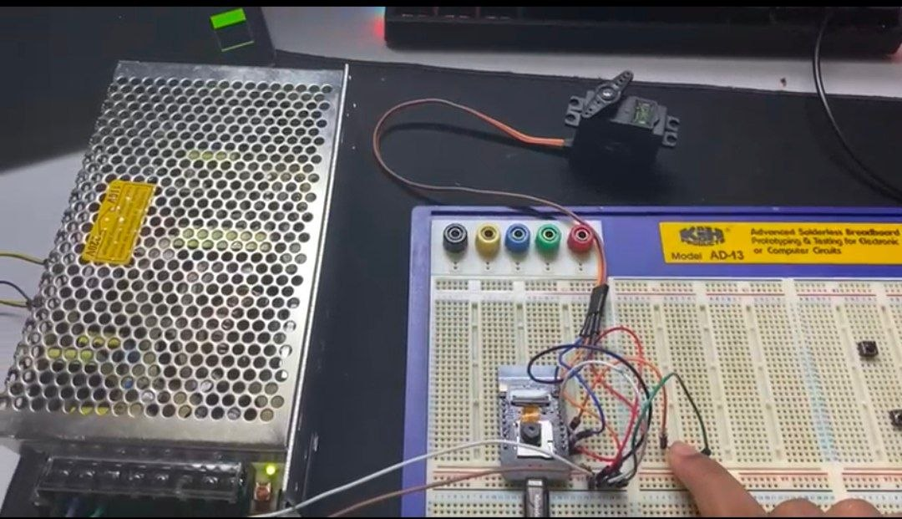  The servomotor is at 0°. | 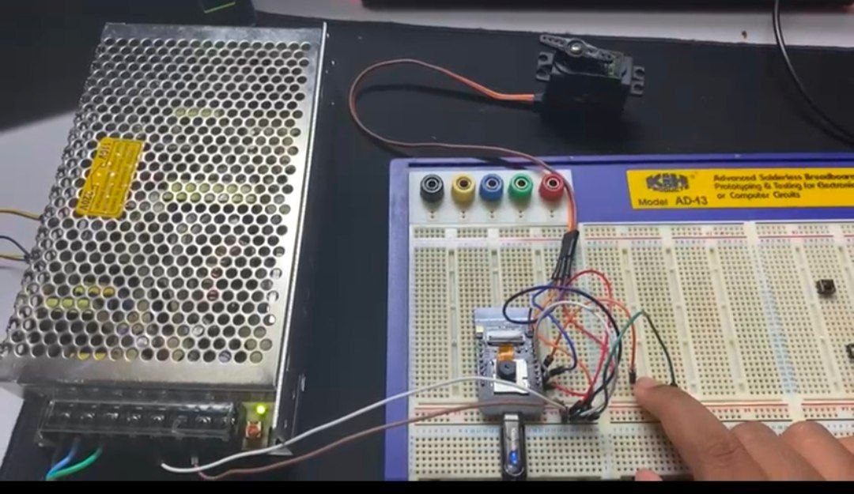  The servomotor at 180°.

Task 2.
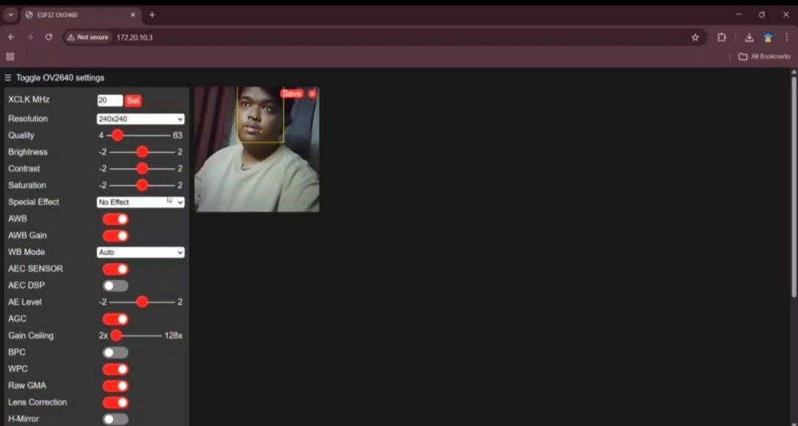
Figure 2. Shows the web UI with the "Face Detection" toggle turned ON and a bounding box around a detected face.

DATA ANALYSIS
The experimental results demonstrate a successful integration of wireless communication, digital signal processing, and mechatronic actuation.
Task 1: Manual Control and Discrete Signal Handling
In the first task, we successfully modified the standard web server code to implement a manual trigger. By defining GPIO 13 as an input with an internal pull-up resistor, we created a stable control loop. As shown in the data table, the system maintained a logic HIGH state while the button was idle, which kept the servo stationary. When the button was pressed, it completed the circuit to GND, resulting in a logic LOW signal that triggered the 0° to 180° panning sequence. This confirmed our objective of using discrete inputs to interrupt and control automated mechatronic movements. The use of an external 5V 2A power supply was critical here; we observed that without it, the servo movement caused voltage drops that would have interrupted the Wi-Fi stream.

Task 2: Automated Face Detection and System Synchronization
For the intermediate task, the system transitioned from manual control to autonomous tracking. By enabling the face detection feature in the web interface, we utilized the ESP32’s digital signal processing to identify facial features within the OV2640 camera's field of view. The software successfully translated the detected face's position into a coordinate system. We used these coordinates as a feedback mechanism to drive the servo motor. When a face moved away from the center of the frame, the code calculated the error in coordinates and adjusted the PWM signal to the servo to re-center the camera. This synchronization between software-based vision and physical hardware response effectively transformed the prototype into a "smart" surveillance system capable of active subject tracking.

RESULTS
The results of the experiment demonstrate that the ESP32-CAM module successfully integrated wireless video streaming with real-time mechatronic actuation. For the first task, we confirmed that the pushbutton on GPIO 13 functioned as an effective manual trigger. By using an internal pull-up resistor, the system remained stable at a logic HIGH (3.3V) state while idle, keeping the servo stationary. When the button was pressed, it pulled the signal to logic LOW (0V), which immediately initiated the horizontal panning sequence from 0° to 180°. As shown in Figure 1, the servo successfully reached its mechanical limits, providing a wide field of view for the camera. This confirmed our ability to use discrete signal inputs to interrupt and control the surveillance hardware manually.

In the second task, the system transitioned to automated feature detection by utilizing the ESP32-CAM's digital signal processing capabilities. As seen in the web interface in Figure 2, the "Face Detection" feature was successfully activated, allowing the software to identify facial features and frame them with a bounding box. This task proved that the camera could interpret human features and map them to a coordinate system. By using these coordinates as a feedback mechanism, we were able to synchronize the software's vision logic with the servo motor's physical movement. This allowed the camera to adjust its angle autonomously to keep a detected face centered, transforming the prototype into a smart, self-adjusting surveillance system.

Throughout these tasks, the technical setup was critical to maintaining system stability. By selecting the "Huge APP" partition scheme and using a dedicated 5V 2A external power supply, we avoided common issues like memory overflow or Wi-Fi disconnection caused by the servo's high current draw. These results show that the project met all its primary objectives, successfully bridging digital signal processing with real-time automation in a mechatronic context.

DISCUSSION
The experimental findings demonstrate that the ESP32-CAM is a versatile platform for merging IoT connectivity with mechatronic control. In the first task, our modification of the standard web server code to include a manual trigger proved how discrete digital inputs can effectively override automated routines. By utilizing the internal pull-up resistor on GPIO 13, we ensured a stable signal that prevented accidental triggers from floating voltages. The logic worked perfectly; the system remained idle during the logic HIGH state and initiated the panning sequence only when the button was pressed to create a logic LOW. A critical takeaway from this part of the lab was the importance of power management. We noticed that using a dedicated 5V 2A power supply was non-negotiable because the high current drawn by the servo motor would otherwise cause the ESP32 to brownout, leading to disconnected Wi-Fi streams.
Moving into the second task, we saw the true potential of "smart" surveillance by leveraging the module's digital signal processing for face detection. This shifted the system from a simple motorized camera to an autonomous tracking unit. The ability of the software to identify facial features and map them onto a coordinate system provided a real-time feedback loop. This data allowed the servo to make corrective adjustments, proving that we could successfully synchronize complex vision algorithms with physical hardware responses. While there was some slight latency in tracking, the integration showed a robust bridge between the digital environment of the web interface and the physical movement of the camera mount.

CONCLUSION
This experiment successfully achieved all the primary objectives related to the development of a smart surveillance prototype. We effectively established a wireless video stream using the OV2640 module and integrated mechatronic actuation through PWM-controlled servo panning. By completing both the manual control task and the automated face tracking task, we demonstrated a clear understanding of how to handle discrete signal inputs and how to interpret digital signal processing data for autonomous hardware responses.
The lab also reinforced essential hardware interfacing techniques, particularly regarding the use of external power sources for actuators and the management of memory partitions for complex firmware. Ultimately, this project provided a practical foundation in sensor fusion and system synchronization, showcasing how IoT-enabled devices can be transformed into intelligent, responsive mechatronic systems within a security and surveillance context.

RECOMMENDATIONS
- Implement a Dedicated Power Rail: To ensure long-term system stability, a dedicated power distribution board should be used to separate the microcontroller’s logic power from the servo motor's high-current supply. This prevents electrical noise or voltage dips from causing Wi-Fi disconnections during active tracking movements.
- Optimize Frame Rate for Autonomous Tracking: While high-resolution settings like UXGA provide clearer images, they increase processing latency. For smoother tracking performance, the frame size should be locked at QVGA or CIF to increase the frames per second (FPS), allowing the servo to respond more fluidly to a subject's movement.
- Integrate Signal Filtering: To improve the professionalism of the video stream, a "dead-band" or low-pass filter should be implemented in the software. This would prevent the servo from jittering when a detected face is already near the center of the coordinate system, resulting in more stable surveillance footage.

REFERENCES
[1] https://randomnerdtutorials.com/program-upload-code-esp32-cam/
How to Program / Upload Code to ESP32-CAM AI-Thinker (Arduino IDE)
[2] https://my.cytron.io/p-ch340-usb-to-ttl-serial-cable
CH340 USB to TTL Serial Cable
[3] https://arduino-er.blogspot.com/2020/09/program-esp32-cam-using-ftdi-adapter.html
Program ESP32-CAM using FTDI adapter
[4] https://www.youtube.com/watch?v=D3MPBPGT3cw
Program ESP32-CAM using FTDI adapter
[5] https://core-electronics.com.au/guides/esp32-cam-set-up/
[6] https://www.youtube.com/watch?v=Y7LWcAwzpPE

ACKNOWLEDGEMENT

We would like to express our deepest appreciation to our instructor, Assoc. Prof. Eur. Ing. Ir. Ts. Gs. Inv. Dr. Zulkifli Bin Zainal Abidin, for his invaluable guidance, continuous support, and constructive feedback throughout the completion of this project. His expertise and dedication have been instrumental in deepening my practical and theoretical understanding of mechatronics engineering. Furthermore, we are grateful to the Department of Mechatronics Engineering at the International Islamic University Malaysia for providing the necessary laboratory facilities and a conducive environment that made this work possible.

STUDENTS DECLARATION

We hereby declare that the work presented in this technical report is entirely our own, except where explicitly acknowledged. We certify that in developing and completing this mechatronics project, we have strictly adhered to the standards of academic integrity and have not engaged in any form of plagiarism or unethical conduct. All sources of information, reference materials, and technical support utilized in this work have been appropriately cited and acknowledged.

Certificate of Originality and Authenticity

This is to certify that we are responsible for the work submitted in this report, that the original work is our own except as specified in the references and acknowledgment, and that the original work contained herein has not been untaken or done by unspecified sources or persons. We hereby certify that this report has not been done by only one individual, and all of us have contributed to the report. The length of contribution to the reports by each individual is noted within this certificate. We also hereby certify that we have read and understand the content of the total report, and no further improvement on the reports is needed from any of the individual contributors to the report. We therefore agreed unanimously that this report shall be submitted for marking, and this final printed report has been verified by us.

Signature: IrfanHakimi Read[/]
Understand[/]
Name: Muhammad Irfan Hakimi Bin Mohd Rizuan Agree[/]
Matric : 2416289

Signature: Najmi Read[/]
Understand[/]
Name: Muhammad Najmi Bin Mohd Azam Agree[/]
Matric : 2128653

Signature: Shahabudin Read[/]
Understand[/]
Name: Muhammad Shahabudin bin Ishak Agree[/]
Matric : 2120279

